LP Services system update – October 2025

- Learning Provider Portal – System enhancements delivered
Summary | Description | Implementation date
CoC Submission Report | The CoC submission report is now located alongside all the other reports within the LP Portal in the reports tab in financial reports. | 12/10/25
CoC Submission Report | Within the CoC submissions report, the Learning Aim Details heading will display as a hyperlink:  When you select the link, a breakdown of Learning Aim Type CoCs, totals and percentage of learning aims and percentage of total CoCs is displayed:  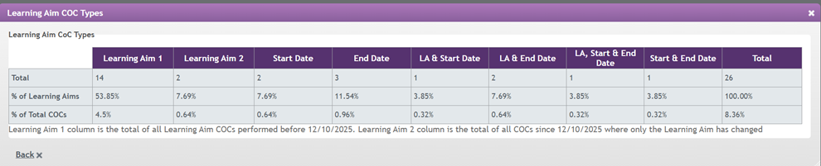  Please note: Column - Learning Aim 1 is the total of all learning aim CoCs performed prior to 12/10/25 and Column - Learning Aim 2 is the total of all learning aim CoCs after 12/10/25, where only the Learning Aim has changed. | 12/10/25
Payment Instlament Report (PIR) | Added a new ‘Number’ column to the left hand side of the PIR and export which will show the total amount of applications included in each row.  Removed the “Submitted and Progressing Applications” box section at the top of the report. | 24/08/25
Payment Instlament Report (PIR) | Added an ‘Awaiting Validation’ row within the not approved for payment section on the PIR and the export facility, to give visibility of applications awaiting further evidence. | 27/07/25
CoC Effective Date | Removed the pre-population of the CoC effective date. Rather than defaulting to the current system date, you will have to enter the effective date. This will be mandatory and if no date has been entered an error message will be displayed. | 27/07/25
Correspondence Section - Missing Evidence hyperlink | For “Identity’, within the Missing Evidence link in the Assessment Information tab, the reference to ‘ADIF’ has been removed as an evidence document and the description for ‘Birth Certificate’ has been updated to advise that either a photocopy or original is now acceptable. | 27/07/25
Payment Instalment Report (PIR) | With the introduction of E-Signature, applications no longer go to the workstage of ‘Approved Awaiting Signature’. This column has been removed from view within the PIR as well as the export facility. | 27/07/25
Withdrawal error message | Update error message when performing a Withdrawal Change of Circumstance (CoC) where the Effective Date falls on a month where the current status is ‘Not in Attendance’. This is to make it clearer as to why the CoC is not accepted. | 08/06/25
Update withdrawal validation rules | To make sure all attendance confirmations are up to date before performing a ‘Withdrawal’ Change of Circumstance. We'll prevent you from performing a 'Withdrawal' Change of Circumstance with an effective date before an outstanding ‘Awaiting Confirmation' attendance. If this is currently enabled for confirmation. | 23/03/2025
Update suspension validation rules | To make sure all attendance confirmations are up to date before performing a ‘Suspension’ Change of Circumstance, we'll prevent users from performing a 'Suspension' Change of Circumstance with an effective date before an outstanding ‘Awaiting Confirmation' attendance. If this is currently enabled for confirmation. | 23/03/2025
Attendance confirmation status - suspension | To make sure applications and attendance confirmations are correctly maintained. A ‘Suspension’ Change of Circumstance, the ‘Current Payment Schedule & Attendance’ will show all months which are after the month of the suspension effective date as ‘Awaiting Confirmation’. | 23/03/2025
New reports tab | Within the Learning Provider Portal, to make sure of better navigation, we've created a new ‘Reports’ tab within the Home Page. This will hold sub menus of all current reports.  - Financial reports - Loan Position, Remittance, Loan Facility Details & Payment Instalment Report  Access to the reports and all functionality within the reports page will remain the same. | 26/01/2025
New maintenance tab | Within the Learning Provider Portal, to ensure better navigation, we've created a new ‘Maintenance’ tab within the Home Page. This will hold sub menus of all current Maintenance functionality:  - maintain users  - maintain groups  Access to the maintenance page and all functionality within them will remain the same. | 26/01/2025
Withdrawal CoC | Prevents providers being able to submit withdrawals with an effective date that is after the course end date. | 10/11/2024
View CoC page | Removed the default search of ‘Processed’ within the 'View CoC' screen to allow users to see all CoCs performed. On entry to the View CoC screen, there will be no selection of a default value within the search functionality. | 28/07/2024
Maintain groups page | The search criteria will default to ‘Hide Inactive Groups’ and only display ‘Active’ groups. | 28/07/2024
Learner search page and export payment schedule & attendance | LP Portal will show ‘awaiting confirmation' for any month following a suspension where there has not been a payment made. | 28/07/2024

- Learning Provider Portal – System enhancements under analysis

Summary | Description | Status
Detailed Learner Information/Assessment Information/Application State | Add hyperlink to awaiting validation status to show what evidence is required and has been requested from the learner. | Under analysis
Loan Position Report (LPR) | Removal of the LPR, as all information is now available within the PIR. | Under analysis
CoC Worklist | Add the facility to export the data. | Under analysis
CoCs | To enable Providers to submit a fee change CoC at the same time as withdrawing an application, where it has previously been suspended. | Under analysis
Learning Provider Details page | De-activate both the Profile and Contract Manager edit buttons. Any changes the Learning Provider attempts to submit are not updated via the LP Portal. | Under analysis

